Tuesday 23/06/26
SQL ANSWER SHIT DAY 3

- Top 5 highest salary employees
Ans :- SELECT DISTINCT salary FROM Employee
ORDER BY salary DESC LIMIT 1 OFFSET 4;

- Department wise employee count 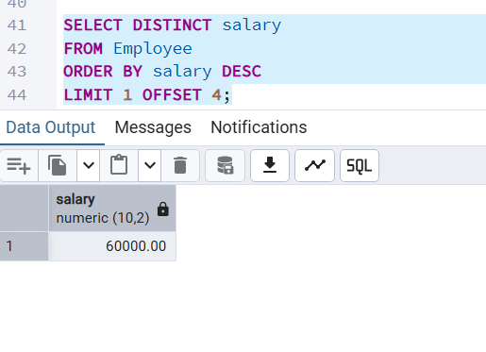
Ans:- SELECT dept_id COUNT(*) AS employee_count
FROM Employee GROUP BY dept_id;
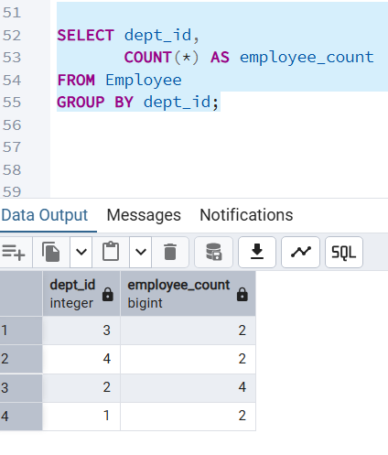
- Find Second highest salary
Ans:- select max(salary) from Employee
Where salary<(select max(salary) from Employee);
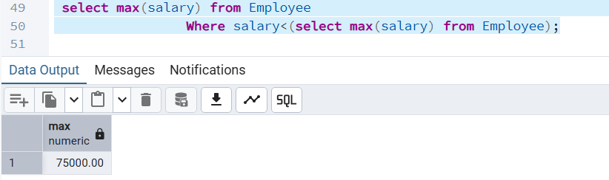
- Employees whose salary > department average salary
Ans:- SELECT emp_id,emp_name,
salary,
dept_id
FROM Employee e
WHERE salary >
(
SELECT AVG(salary)
FROM Employee
WHERE dept_id = e.dept_id
);
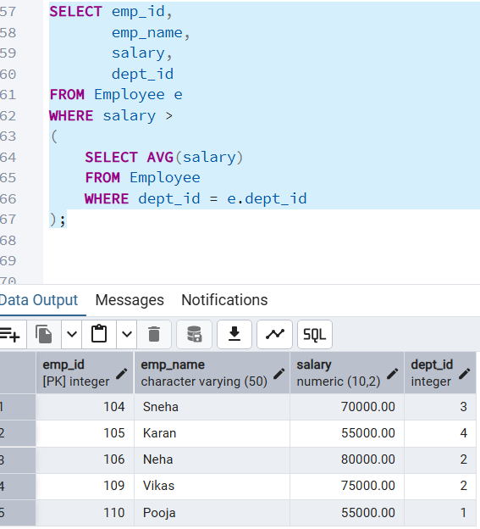

- Inner join
SELECT e.emp_id,
e.emp_name,
d.dept_name
FROM Employee e
INNER JOIN Department d
ON e.dept_id = d.dept_id;
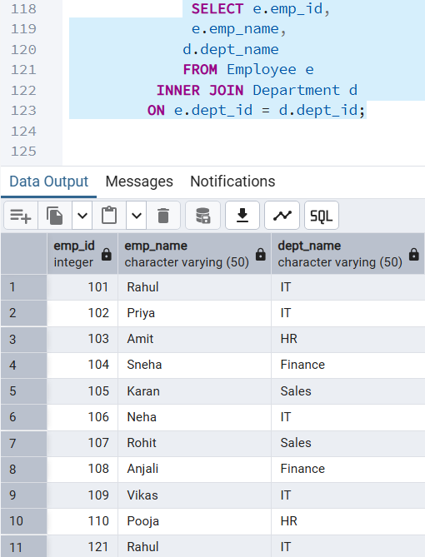

- Left join
SELECT e.emp_id,
e.emp_name,
d.dept_name
FROM Employee e
LEFT JOIN Department d
ON e.dept_id = d.dept_id;
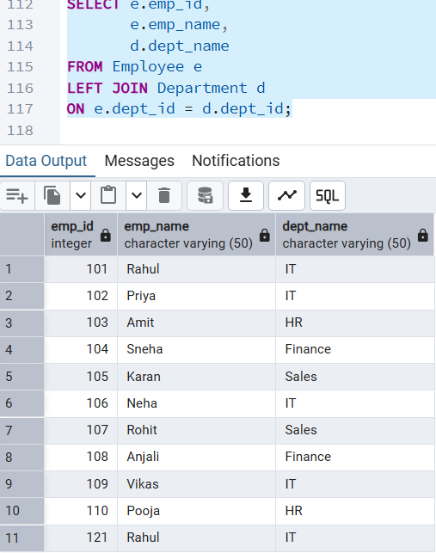

- Group by with having
check whether department 2 has more than 1 employee:
SELECT dept_id,
COUNT(*) AS emp_count
FROM Employee
WHERE dept_id = 2
GROUP BY dept_id
HAVING COUNT(*) > 1;
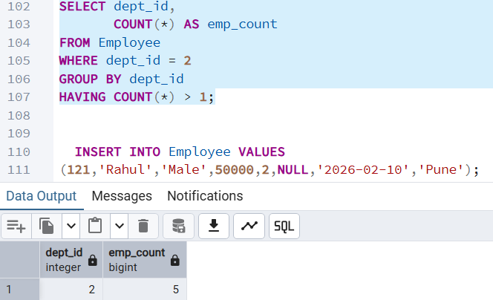
- Employees hired in last 6 months
SELECT *
FROM Employee
WHERE join_date >= CURRENT_DATE - INTERVAL '6 months';
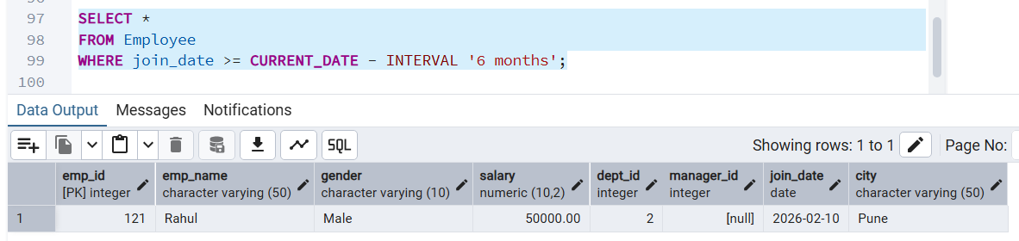
9. Find the Duplicates records
SELECT emp_name,salary,dept_id, COUNT(*)FROM Employee
GROUP BY emp_name, salary, dept_id HAVING COUNT(*) > 1;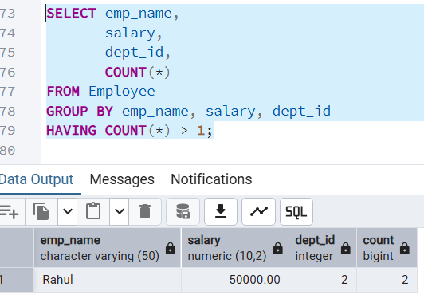
10.How to remove the duplicates record
Ans:- • DISTINCT
• GROUP BY
• ROW_NUMBER() + Delete (most preferred)
• MIN()/MAX() with Delete
• Temporary table approach
(To find duplicates )
SELECT emp_name,
salary,
dept_id,
join_date,
COUNT(*)
FROM Employee
GROUP BY emp_name, salary, dept_id, join_date
HAVING COUNT(*) > 1;
(To delete duplicates)
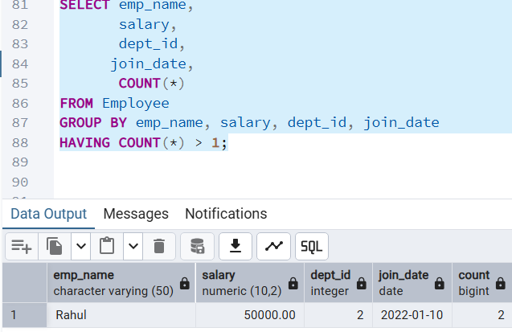

(to delete duplicates)
DELETE FROM Employee
WHERE emp_id NOT IN (
SELECT MIN(emp_id)
FROM Employee
GROUP BY emp_name, salary, dept_id
);
